Yuwen Sang

COMP 3421 A5

**Q1: Find all info about managers who are 26 or younger and live in CA**

mysql> Select * from Manages M, Employee E where M.eid = E.eid and E.age <= 26 and E.residenceState = "CA";

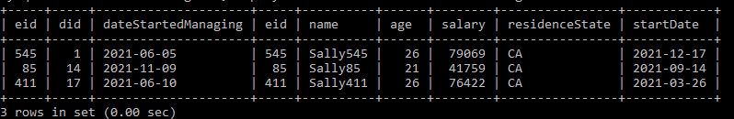**Q2: Find the name and salary of managers who earn less than 35000**

mysql> Select E.name, E.salary from Employee E, Manages M where E.eid = M.eid and E.salary < 35000;

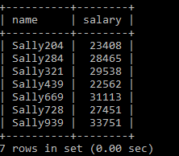

**Q3: Find the eid and startDate of managers who started working before Feb 1, 2021**

**-- i.e., startDate < "2021-02-01"**

mysql> Select E.eid, E.startDate from Manages M, Employee E where M.eid = E.eid and E.startDate < "2021-02-01";

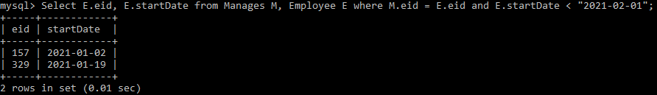

**Q4: Find the name of the employee who manages the "department40" department**

mysql> Select E.name from Employee E, Manages M, Department D where E.eid = M.eid and M.did = D.did and D.name = "department40";

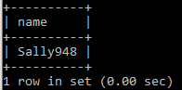

**Q5: Find the eid of employees who work in exactly 3 departments**

**-- Hint: use aggregates/group by/having**

mysql> select W.eid from WorksFor W group by W.eid having count(W.did) = 3;

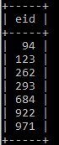

**Q6: Find the eid, residenceState, and did for all those 20 year old**

**-- employees that work in a department located in the same state that they live in.**

mysql> Select E.eid, E.residenceState, W.did

-> from Employee E, WorksFor W, Department D

-> where E.eid = W.eid and D.did = W.did and E.age = 20 and E.residenceState = D.stateLocated;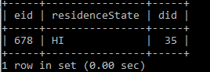

**Q7: Find the eid, residence state, did, and department state**

**-- for every managers who manages a department located in AK**

mysql> Select M.eid, E.residenceState, M.did, D.stateLocated from Employee E, Manages M, department D where E.eid = M.eid and D.did = M.did and D.stateLocated = "AK";

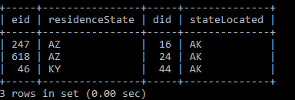

**Q8: Find the eid, residence state, did, and deparment state for**

**-- every employee that works for a department located in CO**

mysql> Select E.eid, E.residenceState, D.did, D.stateLocated

-> from Employee E, Department D, WorksFor W

-> where E.eid = W.eid and D.did = W.did and D.stateLocated = "CO";

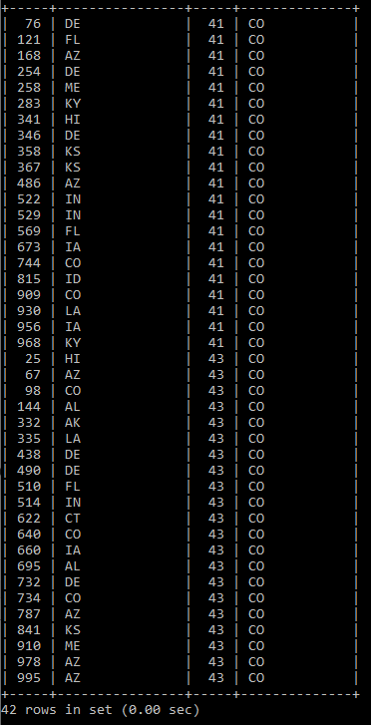

**Q9: find the eid of employees who are managing two or more departments**

mysql> Select M.eid

-> from Manages M

-> group by M.eid

-> having count(M.did) >= 2;

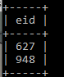

**Q10: find eid, did, and manging starting date for all employees found in the previous problem**

**-- Hint: use "in" and a nested query**

mysql> Select M.eid, M.did, M.dateStartedManaging

-> from Manages M

-> where M.eid in (

-> select M2.eid from Manages M2 group by M2.eid having count(M2.did) >= 2);

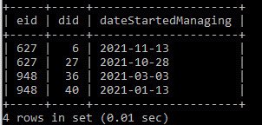

**Q11: find the did and number of empolyees for every department with 14 or fewer employees**

mysql> Select W.did, count(W.eid)

-> from WorksFor W

-> group by W.did

-> having count(W.eid) <= 14;

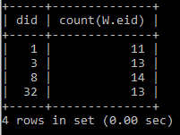

**Q12: Find the average employee salary for each department whose did is < 6.**

**-- In other words, for each of those departments find the average salary of employees**

**-- who work for that department**

mysql> Select W.did, avg(E.salary)

-> from WorksFor W, Employee E

-> where W.eid = E.eid and W.did < 6

-> group by W.did;

